

<Name-of-Software-Application>

# **CS 230 Project Software Design Template**

Version 1.2

## Table of Contents

**CS 230 Project Software Design Template**1

**Table of Contents**2

**Document Revision History**2

**Executive Summary**3

**Design Constraints**3

**System Architecture View**3

**Domain Model**3

**Evaluation**3

**Recommendations**5

## Document Revision History

| Version | Date | Author | Comments |
| --- | --- | --- | --- |
| 1.0 | 11/15/2020 | Jeremia Faust | Initial document |
| 1.1 | 11/29/2020 | Jeremia Faust | Updated evaluation |
| 1.2 | 12/13/2020 | Jeremia Faust | Updated Recommendations |

**Instructions**

Fill in all bracketed information on page one (the cover page), in the Document Revision History table, and below each header. Under each header, remove the bracketed prompt and write your own paragraph response covering the indicated information.

## Executive Summary

The Gaming room has approached Creative Solutions to develop a web-based game called Draw it or Lose it. Using the rules given to the game one will need to be available across all available platforms to reach as many consumers as possible. It is very important to have unique identifiers in each instance for game, id, and player.

## Design Constraints

Designing a game application for a web-based distributed environment can limit features that are available that would otherwise be available on a downloadable application. By limiting the game to a web-based environment you are limited to the web software and not as much the hardware that is using the web software. Essentially if the web software will work on a device the game should also work on that device.

It is important to have the design constraints on application development because it provides direction. Too much freedom tends to limit the creativity to work around a problem. According to David Arcila there are four main constraints: Theme, time, team, and tools. By keeping these in mind you can think ahead about the possible constraints that can guide development. Constraints not only allows developers to think creatively but it limits the scope of a project. The saying “makes the project just good enough” is very important because there is such a thing as too many features.

## System Architecture View

Please note: There is nothing required here for these projects, but this section serves as a reminder that describing the system and subsystem architecture present in the application, including physical components or tiers, may be required for other projects. A logical topology of the communication and storage aspects is also necessary to understand the overall architecture and should be provided.

## Domain Model

The gaming room UML diagram shows the parent class Entity and three child classes that are inherited from the entity class. That means that the classes Game, Team and Player objects from the entity class. The child classes have all the objects of the Entity class with their own encapsulated objects. The Game Service class has a relationship with the game class, the game then has a relationship with the team class and finally the team class has a relationship to the player class. Which means that they have references to the classes they are related to.

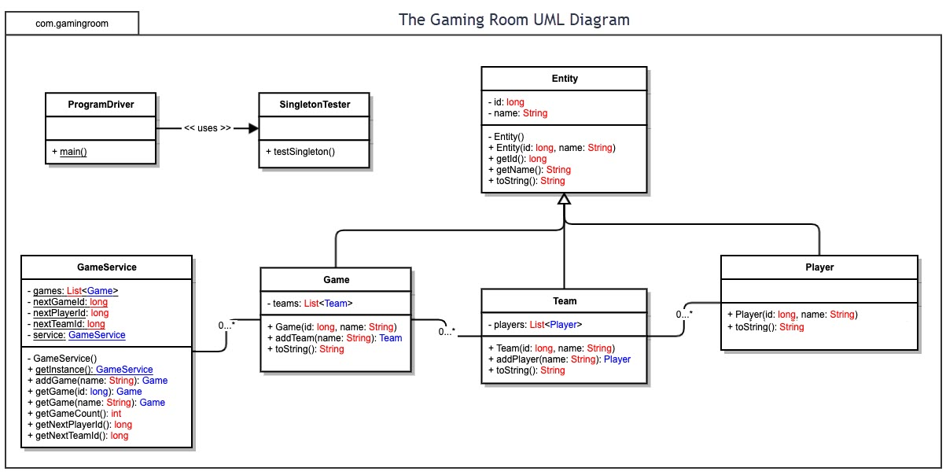

## Evaluation

Using your experience to evaluate the characteristics, advantages, and weaknesses of each operating platform (Linux, Mac, and Windows) as well as mobile devices, consider the requirements outlined below and articulate your findings for each. As you complete the table, keep in mind your client’s requirements, and look at the situation holistically, as it all has to work together.

In each cell, remove the bracketed prompt and write your own paragraph response covering the indicated information.

| **Development Requirements** | **Mac** | **Linux** | **Windows** | **Mobile Devices** |
| --- | --- | --- | --- | --- |
| **Server Side** | The mac is the second most popular OS on the market. Since the mac is proprietary with its hardware you are limited to Mac hardware. To run a webserver, it will be required additional software called MAMP. You will also need to install a content management system. The MAC-OS alone no longer allows for website hosting. | Linux is an open-source operating system, thus is very versatile and very reliable in supporting the needs of businesses. Since it is an open-source program it does require a degree of experience to fully utilize the program. For website hosting it uses an FTP client to upload your files and it uses a public _html as the root directory. To manage the website, you will need a content management system. | Window server is the most popular OS used but does require a little know how to navigate. Window is also the most taught program in schools so most navigation problem are mitigated. Because of the popularity of Windows, it tends to be hacked more than any other OS so increased security is needed to protect user data. It has all the tools needed to host websites built right into the server OS. | Mobile Device are limited to their hardware. Since they are very limited in power compared to computers, they tend to have less web-based features. Mobile devices tend to be user devices and can use a remote user interfaces with server but is not used as servers themselves |
| **Client Side** | The mac is not really used as much in program development and not taught in schools as part of the regular program, so it requires additional resources to program. The cost to use Mac-OS server is 19.99 a month from the Mac App Store. You can use old mac computers as a server. The UI is very user friendly and you can control all other mac on iPhone from it. It seems to me it is not really a good choice to use for a business, it looks to me to be set up for home users | Linux It is very difficult navigate for clients due to the open-source nature of the program but there are many companies that have their own version such as Ubuntu Masters 4. There are no licensing fees but most likely will require external support to run and maintain the servers. Red Hat charges roughly 2500 a year. | Window servers are very expensive compared to other OS. If you are just a small business, it cost 500 dollar a year, but a datacenter will cost around 6000 dollars a year. That is not including the cost of support Red hat charges 1500 a year. Those prices are negotiable with a Microsoft representative. Programing for window in very easy because it is what is taught to you in your programing classes. | Mobile devices are very user friendly. The OS are easy to program for and tend to be very flexible. |
| **Development Tools** | The main program language for mac is swift and Objective-c. Java is also used. | Linux is designed to use multiple programming languages. Currently C and C++ is used mostly but has support for many more | Window uses mainly C++ and can use most languages. | JavaScript is mostly used for programs that need the ability to work on multiple OS |

## Recommendations

Analyze the characteristics of and techniques specific to various systems architectures and make a recommendation to The Gaming Room. Specifically, address the following:

1. **Operating Platform**: The platform that I recommend to use is Windows cloud server such as Azure. Windows is very easy to use and provides allot of support along with developer tools.
2. **Operating Systems Architectures**: The Windows operating system uses a process called symmetric multiprocessing which allows program to run much faster. With a program such as Draw It or Lose It, that runs multiple games at once this processing will allow seamless gameplay. The use of the command prompt allows for quick and easy management
3. **Storage Management**: Windows has an easy-to-use storage management already in place with features such as single disk with partitions to external storage arrays. With the use of cloud servers there will be more than enough storage without the need of buying hardware.
4. **Memory Management**: Windows servers can use both physical and virtual memory. Virtual memory is unlimited with up to 2 gigs for each process. Other memory features for windows are memory mapped files, copy-on-write memory, large memory support.
5. **Distributed Systems and Networks**: Since this is a web-based program, the use of servers and high bandwidth internet with be needed to maintain the many different game instances. An account server will be needed to maintain many client accounts. Backup power and servers are recommended in the case of emergencies. With the use of cloud services, a lot of this is will be mitigated to the Cloud service but is recommend keeping an onsite back up for anything on the cloud. It can be expensive to recover data from a cloud server if there is a problem. One other thing about cloud services that may be a problem is timing out on requests between the client and the server, thus interrupting services.
6. **Security**: Security is a must-have for the client. It is recommended to use an encrypted account server that interacts with the main server. This can be done with three tips that john Hughes from wpbackitup.com, Harden Your wp-config.php File to Protect Database Information, Disable XML-RPC to Prevent DoS Attacks, and Hide Your WordPress Version to Keep Vulnerabilities Unexposed. Windows servers also has a robust security system in place to protect data. They are built from the ground up with security in mind. Windows servers a robust user account control with administers having complete control on what each user has access to. Window also has a credential guard and a remote credential guard to “to protect in-memory hashes and Kerberos tickets”(Leos Marek). This protects the server by preventing other sources of implanting credentials on the server, thus prevents future access with permission.

# Works Cited

Arcila, D. (2012, November 01). Constraints Are an Essential Aspect of Game Development. Retrieved November 15, 2020, from <https://gamedevelopment.tutsplus.com/articles/constraints-are-an-essential-aspect-of-game-development--gamedev-1448>

Contributors, T. (2017, December 28). What is Microsoft Windows Server OS (operating system)? - Definition from WhatIs.com. Retrieved December 13, 2020, from https://searchwindowsserver.techtarget.com/definition/Microsoft-Windows-Server-OS-operating-system

Get Mac Hosting as low as $2.95 per month!, &amp; Name. (2019, March 25). How to Turn Your Mac Into a Web Server. Retrieved November 28, 2020, from <https://blog.machighway.com/2019/04/16/how-to-turn-your-mac-into-a-web-server/>

Hughes, J. (2017, November 28). Server-Side Security: 3 Tips to Keep Your Website Safe. Retrieved November 15, 2020, from <https://www.wpbackitup.com/blog/server-side-security-tips>

Leoni, K. (n.d.). Linux vs Windows – a cost comparison. Retrieved November 28, 2020, from <https://blog.heroix.com/blog/linux-vs-windows-a-cost-comparison>

Leos MarekLeos has started in the IT industry in 1995. For the past 15+ years he focused on Windows Server. (2019, October 02). Windows Server security features and best practices. Retrieved December 13, 2020, from https://4sysops.com/archives/windows-server-security-features-and-best-practices/

MacOS Server. (n.d.). Retrieved November 28, 2020, from <https://www.apple.com/macos/server/>

RAM, virtual memory, pagefile, and memory management in Windows (n.d.). Retrieved December 13, 2020, from https://support.microsoft.com/en-us/help/2160852/ram-virtual-memory-pagefile-and-memory-management-in-windows

Windows Server 2019 Licensing & Pricing. (n.d.). Retrieved November 28, 2020, from <https://www.microsoft.com/en-us/windows-server/pricing>